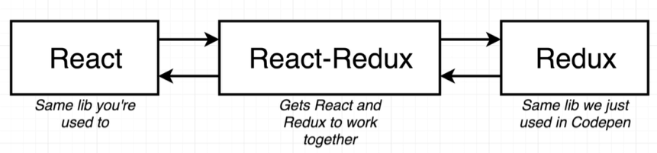

Install dependencies:
npm install --save redux react-redux

Project sketch:
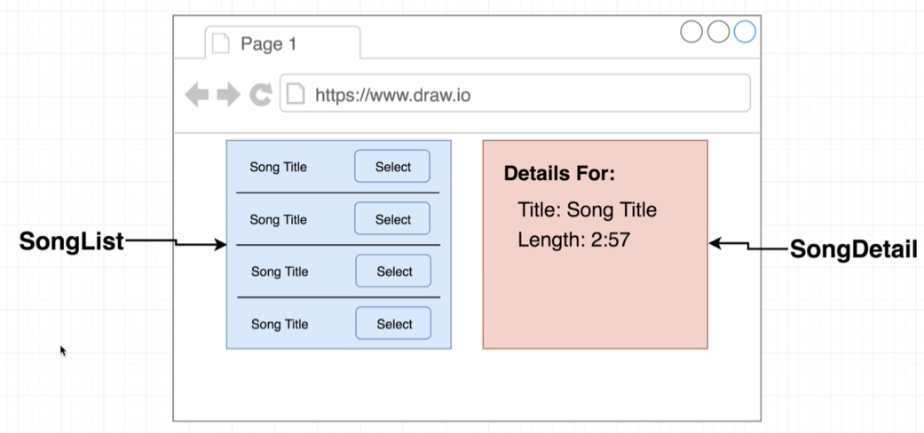

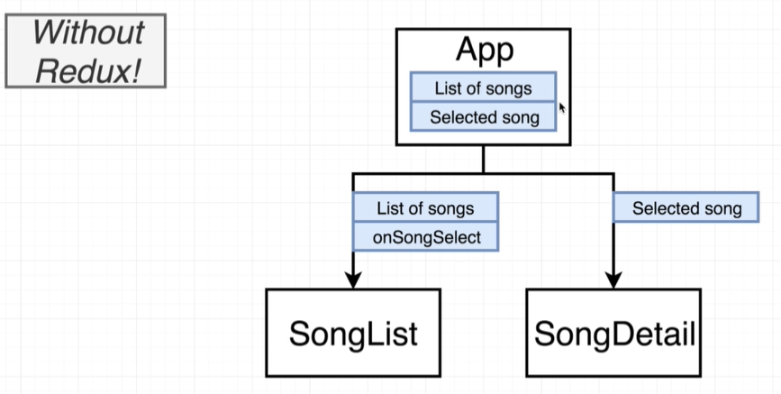

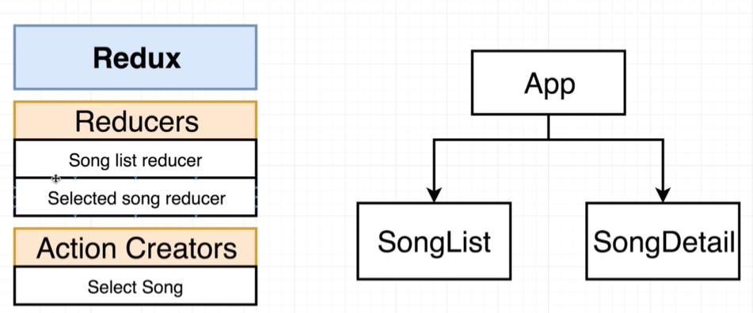

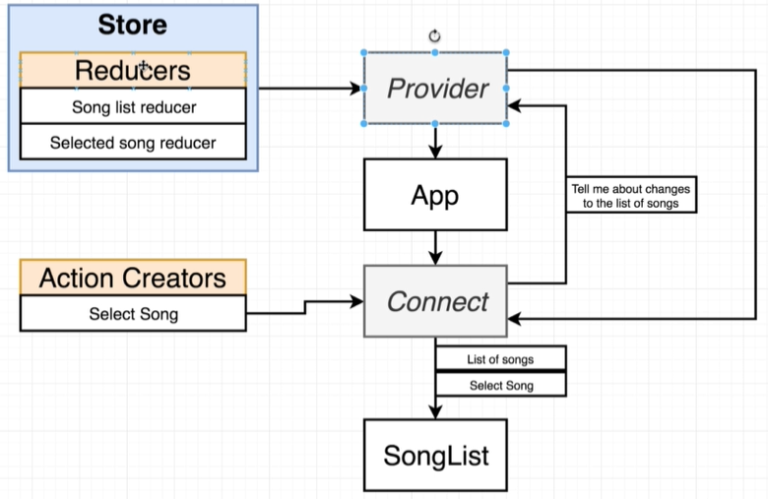
- react-redux creates: Provider and Connect;
- store is a property passed into Provider;
- Create a Connect component right above the SongList and SongDetail component.
- Use Context to communicate between Provider and Connect, even there are components between them.

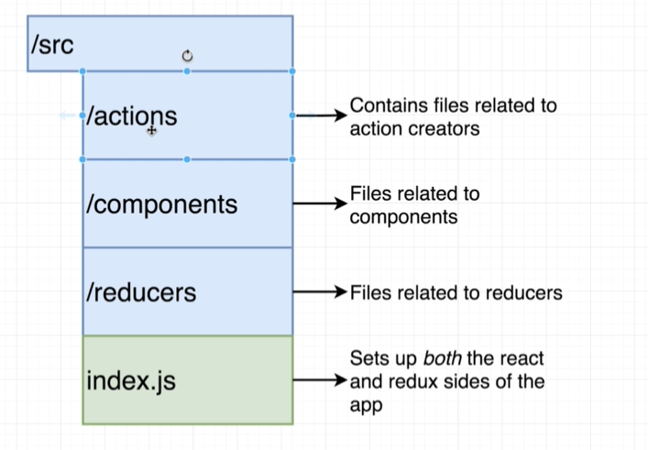

Create an action creator:
// export a named property
export const selectSong =(song)=>{
return {
type:'SELECT_SONG', // compulsary
payload:song // optional
}
}

Create reducers:
// import a named export
import { combineReducer } from 'redux';

const songsReducer = () => {
return [
{
title: "破月",
author: "Alice"
},
{
title: "Rising hope",
author: "Lisa"
},
{
title: "绯色月下",
author: "夜月奈乃"
}
];
};

const selectSongReducer = (selectedSong = undefined, action) => {
// selectedSong is similar to plain React state, this variable will be maintained by a reducer, and this varible changes will cause re-render event
if (action.type === "SELECT_SONG") {
return action.payload;
}

return selectedSong;
};

export default combineReducer({
songs:songsReducer,
selectSong:selectSongReducer
})

index.js config:
import React from "react";
import ReactDOM from "react-dom";
import Songs from "./App";
import { Provider } from "react-redux";
import { createStore } from "redux";
// import a default export
import bundledReducer from "./reducers";

const App = () => {
return (
<div>
<Songs />
</div>
);
};

ReactDOM.render(
<Provider store={createStore(bundledReducer)}>
<App />
</Provider>,
document.querySelector("#root")
);

Use React-Redux connect callback in SongList component:

import React, { Component } from "react";
import { connect } from "react-redux";
import List from "./List";

// import a named export, no need to specify filename if filename is index
import { selectSong } from "../actions";

class SongList extends Component {
constructor(props) {
super(props);
}

render() {
return (
<div className='ui container grid'>
<div className='ui row'>
<div className='column eight wide'>
{/* a standard way to call an action creator, because connect wraps it with store.dispatch and embeds it into props; selectSong() direct calling is useless, it cannot change the data inside store*/}
<List songs={this.props.songs} selectSong={this.props.selectSong}/>
</div>
</div>
</div>
);
}
}

// take data from redux store as state
// get called everytime once action cretors get called
// return these data as props of current component
// convensionally named
const mapStateToProps = (state) => {
// contains all data in store and reducer's return value
console.log('update', state);
return state;
};

const conn = connect(
// pass a function to accept reducer's return value
mapStateToProps,
// wire an action creator with reducers
{
// let the imported action creator as props of this
// call and wrap the action creator into a store.dispatch function
selectSong: selectSong
}
);

export default conn(SongList);

output:
update {songs: Array(3), selectSong: {…}}
selectSong: {title: "Rising hope", author: "Lisa"}
songs: Array(3)
0: {title: "破月", author: "Alice"}
1: {title: "Rising hope", author: "Lisa"}
2: {title: "绯色月下", author: "夜月奈乃"}
length: 3

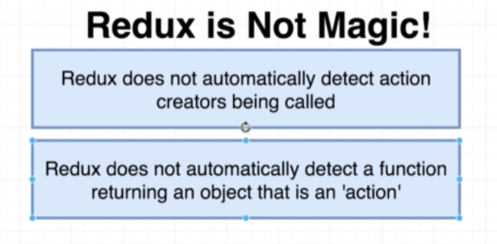

Implementation of SongDetail component:
import React, { Component } from "react";
import { connect } from "react-redux";
import { Message, Label } from "semantic-ui-react";

class SongDetail extends Component {
constructor(props) {
super(props);
}

render() {
console.log(this.props.song);
return (
<div>
<Message color='purple'>
<Message.Header>Title:</Message.Header>
<Message.Header>
{/* initially, the "song" property of props is null, because it is initiated as null inside reducers */}
{this.props.song ? this.props.song.title : "Not seleted"}
</Message.Header>
<div>Author:</div>
<p>{this.props.song ? this.props.song.author : "No infomation"}</p>
</Message>
</div>
);
}
}

const mapStateToProps = (state) => {
console.log("Detail", state.selectSong);
// This key is extremly important, otherwise the returned data cannot be accessed in props
return { song: state.selectSong };
};

export default connect(mapStateToProps)(SongDetail);

